Data Mentor / Career Coach Case Study Interview

Goal: This assignment mimics the real work you’d do at DataShip:
- Creating a roadmap for client (M1)
- Diagnosing a stuck job search and Handling an escalation using our structure (M4)
- Designing/leading interview prep (M5)
We estimate 2–3 hours total as if you are preparing for 1-3 calls with client. When you’ve read this, please reply with your estimated time to complete.
You’ll present your work and potentially do example of running the call with the client in the next interview round.

Note: The use of AI is encouraged, but you must be able to run the call with the plans.
Note: It is a long document only because I tried to give you as much of the context of the client to help you.

What we care about
We will grade you on:
- Communication: clear, simple language; specific instructions a busy client could follow.
- Problem‑solving / coaching: how you diagnose, prioritize, and drive behavior change.
- Module 4 skills: turning job‑search data into a focused 2‑week plan.
- Escalation skill: how you handle a stuck/frustrated client (using our mini playbook).
- Module 5 skills: designing and running a mock interview loop for a data role.
- Ownership: how you structure open‑ended work and stay within a reasonable timebox.
We are not grading prettiness or “perfect” answers. We care about value and clarity.

Context: How DataShip Helps
DataShip is a 1:1 mentorship program for experienced data professionals in the US/Canada (DA/DE/DS/MLE/Analytics Eng/AI Eng) who want faster, better offers.
We mainly solve 4 problems:
- Roadmap: “What’s my fastest, realistic path from here to my next role?”
- Marketing: “My resume/LinkedIn/portfolio don’t show my value.”
- Interview System: “I don’t have a predictable way to get interviews.”
- Interview Skills: “I get interviews but don’t convert them into offers.”
This exercise will focus on (3) Interview System (M4) and (4) Interview Skills (M5).

Client Snapshot:
LinkedIn: https://www.linkedin.com/in/nachiketa-pathak
Goals:
- Minimum: $90k, ideally $120k
- When: ASAP because I need a sponsorship (Note: 6 month money back guarantee)
- Location: USA if I can’t get sponsored in 6 months. I also will have a PR in Canada so that as a fall back.
- Available Time: 40+ hours per week
- Role: DE (open to SWE for the sponsorship) - open any industry, company and location
- Success would look like: Getting more interviews, and being ready and confident going into interview. Also, level up my data engineering skills (SQL, Spark, Python, Databricks). A coach who can identify my gaps and provide a clear roadmap to address them. Someone who sees me as more than just another candidate, taking the time to understand my unique goals, skills, ambitions, and lifestyle. A mentor who is genuinely invested in my success. Going to interviews with confidence. If a recruiter wants me to meet their technical team tomorrow, I want to be ready.
- Coaching Style: I want my coach to be fully honest about my expectations and progress. False promises are not going to make it better.
Data Pre-DataShip
- Time job searching: 4 months
- Applications: 1500
- Interviews: 15
  - 2nd interviews - 6
  - final interviews - 4 (all from recruiter inbound)
  - Offers - 0
- Inbound Screenings - 1-2 per week (DE/SWE)
- Referrals: 2
Time Audit:
- Hours of Sleep a week (Recommended: min 49 or 7 hours daily): 40
- Hours of workout/exercise a week (Recommended: 3.5 or 30 mins daily) : 0
- Hours of school a week: 5
- Hours of French a week: 20
- Hours of Hygiene/self-care a week: 10
- Hours of cooking/eating a week: 15
- Hours of rest/relaxing/dating/fun a week: 20
- Hours of “life” things (kids, groceries, bills, etc) a week: 15
- Hours leftover a week (168 - the total of the above): 42
Struggles
- “I have been vague for planning my day so I would sometime skip on parts of the daily plan”
- “I struggle to go to sleep”
- “I scroll on my phone when I first wake up”
- “Affernoons and evenings I have low energy”
- “I am worried about being left behind, having to start things all over again in a new country, wasted effort of the last few years

Skills:
Check the box for how you will be answering the following checklist. Note: You want to check the one with the most of the boxes in the checklist checked.
- Level 1: Knowledge - Has learnt it
- Level 2: Practical (Entry-level) - Has done or used it in a project or has applicable skills
- Level 3: Data Practitioner (Intermediate) - Confident to do it independently (with Google or AI for support, of course) or lead the project/task
- Level 4: Data Practitioner (Lead) - Can teach others on the topic or lead a team to a solution
Data Engineer - Roadmap
- 1) Mindset & Attitude
- Willingness to continuously learn and improve
- Strong problem-solving skills
- Ability to work with ambiguity and open-ended questions
- Independent learning ability
- Logical and analytical thinking
- Attention to detail
- Systematic and structured approach
- 2) Programming & Scripting
  - Python
- Data Structures (Lists, Tuples, Dictionaries, Sets)
- Control Flow (Loops, Conditionals, Functions)
- Functional Programming (Lambda, Map, Filter, Reduce)
- Object-Oriented Programming (Classes, Inheritance, Polymorphism)
- Exception Handling
- File Handling (CSV, JSON, Parquet, Avro)
- Multithreading and Multiprocessing
- Asynchronous Programming (Asyncio)
- Virtual Environments and Dependency Management (venv, virtualenv, pip, conda)
- Working with APIs (Requests, FastAPI, Flask)
- Data Manipulation Libraries (Pandas, NumPy, Dask)
- Shell & Bash Scripting
- File and Directory Operations
- Process Management
- Environment Variables
- User and Permissions Management
- Cron Jobs and Scheduling
- Text Processing (Grep, Sed, Awk)
- Log Analysis and Monitoring
- 3) Databases & Querying
  - Relational Databases (SQL)
- SQL Basics (CRUD Operations)
- Joins, Subqueries, Window Functions
- Common Table Expressions (CTE)
- Indexing (Clustered, Non-Clustered, Composite, Full-Text)
- Query Optimization and Execution Plans
- Partitioning and Bucketing
- Transactions and ACID Properties
- Stored Procedures and Triggers
- SQL Performance Tuning (Explain Plan, Index Scans, Query Caching)
- NoSQL Databases
- Document Stores (MongoDB, CouchDB)
- Key-Value Stores (Redis, DynamoDB)
- Wide-Column Stores (Cassandra, HBase)
- Graph Databases (Neo4j, Amazon Neptune)
- CAP Theorem, BASE Model
- Data Modeling for NoSQL
- Consistency Levels (Eventual, Strong, Causal)
- Data Warehouses & Data Lakes
- Star and Snowflake Schema
- OLAP vs. OLTP
- Cloud Data Warehouses (BigQuery, Redshift, Snowflake)
- Data Lake Concepts (Delta Lake, Iceberg, Hudi)
- Data Governance, Security, and Compliance
- Data Lifecycle in Data Lakes (Raw, Processed, Curated Layers)
- File Formats & Data Storage
- Row vs. Columnar Storage
- CSV, JSON, XML, Avro, ORC, Parquet
- Compression Techniques (Gzip, Snappy, LZO)
- Serialization & Deserialization
- Data Partitioning and Bucketing Strategies
- Storage Optimization (Z-Ordering, Compacting Small Files)
- 4) Data Processing & Transformation
  - ETL/ELT Concepts
- Data Cleaning and Deduplication
- Data Validation Techniques
- Change Data Capture (CDC)
- Slowly Changing Dimensions (SCD Type 1, 2, 3)
- Incremental vs. Full Data Loads
- Idempotency and Fault Tolerance
- Data Quality Checks and Assertions
- Data Lineage and Provenance Tracking
- Apache Spark (PySpark)
- Core Concepts
- Spark Execution Model (Jobs, Stages, Tasks)
- Resilient Distributed Datasets (RDDs)
- DataFrames and Dataset APIs
- Spark SQL and Query Optimization (Catalyst Optimizer)
- Transformations and Actions (Lazy Evaluation)
- Working with Schema Evolution
- Optimization Techniques
- Partitioning Strategies
- Caching and Persisting DataFrames
- Broadcast Joins and Skew Handling
- Tungsten Optimizer
- Shuffle Operations and Performance Tuning
- Adaptive Query Execution (AQE)
- Data Processing with PySpark
- Reading and Writing Different File Formats (CSV, JSON, Parquet, Avro, ORC)
- Schema Inference and Data Type Management
- Handling Null Values and Missing Data
- Custom UDFs (User Defined Functions) and Performance Considerations
- Working with Timestamps and Date Functions
- 5) Real-Time Data Processing & Streaming
- Apache Kafka
- Kafka Components (Producers, Consumers, Brokers, Topics, Partitions)
- Message Delivery Guarantees (At-Most-Once, At-Least-Once, Exactly-Once)
- Schema Registry and Avro Serialization
- Kafka Streams and KSQL
- Consumer Groups and Offsets
- Kafka Log Compaction and Retention Policies
- Stream Processing
- Structured Streaming with Spark Streaming
- Event Time vs. Processing Time
- Handling Late-Arriving Data and Watermarking
- Stateful Stream Processing
- Integration with Kafka, Flink, and Kinesis
- Sliding and Tumbling Windows
- 6) Data Modeling Concepts
- Core Data Modeling
- Conceptual, Logical, and Physical Data Models
- Normalization and Denormalization
- Entity-Relationship (ER) Modeling
- Primary Keys, Foreign Keys, and Relationships
- Data Constraints and Referential Integrity
- Star Schema vs. Snowflake Schema
- Dimensional Modeling
- Fact Tables vs. Dimension Tables
- Slowly Changing Dimensions (SCD)
- Surrogate Keys vs. Natural Keys
- Data Vault Modeling
- Graph Data Modeling
- Indexing Strategies
- Partitioning and Clustering for Query Optimization
- Data Retention Policies
- 7) Workflow Orchestration
- Directed Acyclic Graphs (DAGs)
- Task Scheduling and Dependency Management
- Apache Airflow (Operators, Sensors, Hooks, Connections)
- Monitoring and Logging in Airflow
- Error Handling, Retries, and Backfill Strategies
- Alternative Workflow Orchestration Tools (Prefect, Luigi)
- 8) Cloud Computing & Infrastructure
- Cloud Service Models (IaaS, PaaS, SaaS)
- Cloud Storage (AWS S3, GCP Cloud Storage, Azure Data Lake)
- Serverless Data Processing (AWS Glue, Google Dataflow, Azure Data Factory)
- Infrastructure as Code (Terraform, CloudFormation)
- Security Best Practices (IAM Roles, VPCs, Data Encryption)
- Cost Optimization and Billing Strategies
- 9) Containers & Infrastructure Automation
- Docker (Images, Containers, Dockerfile, Volumes, Networks)
- Kubernetes Basics (Pods, Deployments, Services, ConfigMaps)
- CI/CD for Data Pipelines (Jenkins, GitHub Actions, GitLab CI/CD)
- Data Pipeline Automation and Monitoring
- 10) Data Engineering in Production
- API Development for Data Services (Flask, FastAPI)
- Serialization and Model Artifacts (Pickle, Joblib)
- Experiment Tracking and Model Monitoring (MLflow, Weights & Biases)
- Logging and Error Handling in Production Pipelines
- Performance Tuning and Cost Optimization
- 11) Non-Technical Skills
- Writing Clear and Concise Documentation (Markdown, Wiki, Notebooks)
- Communicating Technical Concepts to Non-Technical Stakeholders
- Time and Project Management (Agile, Scrum, Kanban)
- Collaboration and Code Reviews
- Business Impact of Data Engineering Decisions
Python:

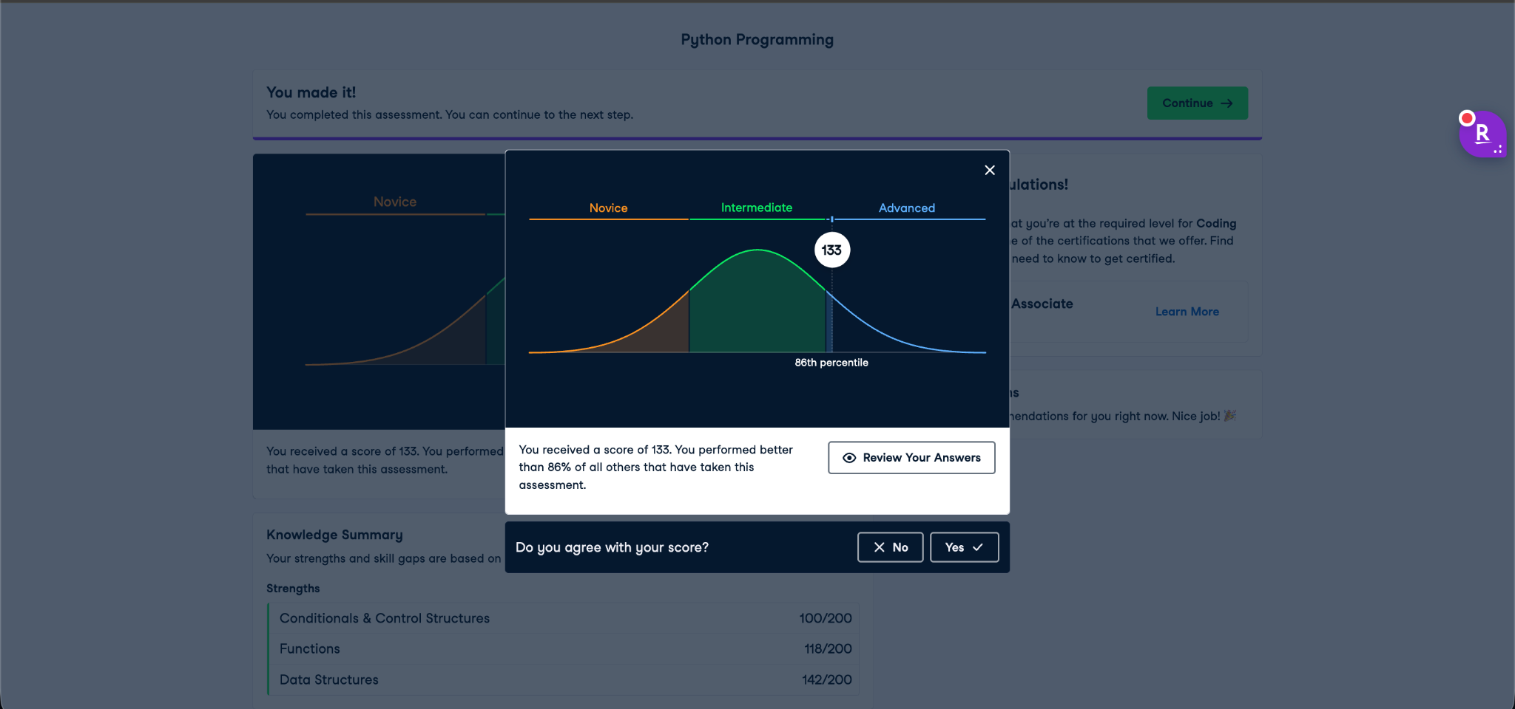
SQL
  - Basic
    - SELECT
    - GROUP BY
    - ORDER BY
    - WHERE
    - LIMIT
    - SUM
    - COUNT
    - AVG
    - JOIN (Same Table Joins)
  - Intermediate
    - Complex JOINS - INNER, LEFT, RIGHT, FULL
    - Unions
    - Subqueries
  - Advanced
    - Query Optimization - This competency includes the ability to demonstrate an understanding of the order of operations performed by the database server and can minimize time and space requirements.
    - Data Modeling - This competency includes the ability to create effective UML diagrams of tables and relationships.
    - Indexing, window functions, pivots - This competency includes understanding the role of indexes in query optimization, designing indexes with appropriate keys to assist in query optimization, using window functions to create trailing averages, running sums, and rotating data using PIVOT.

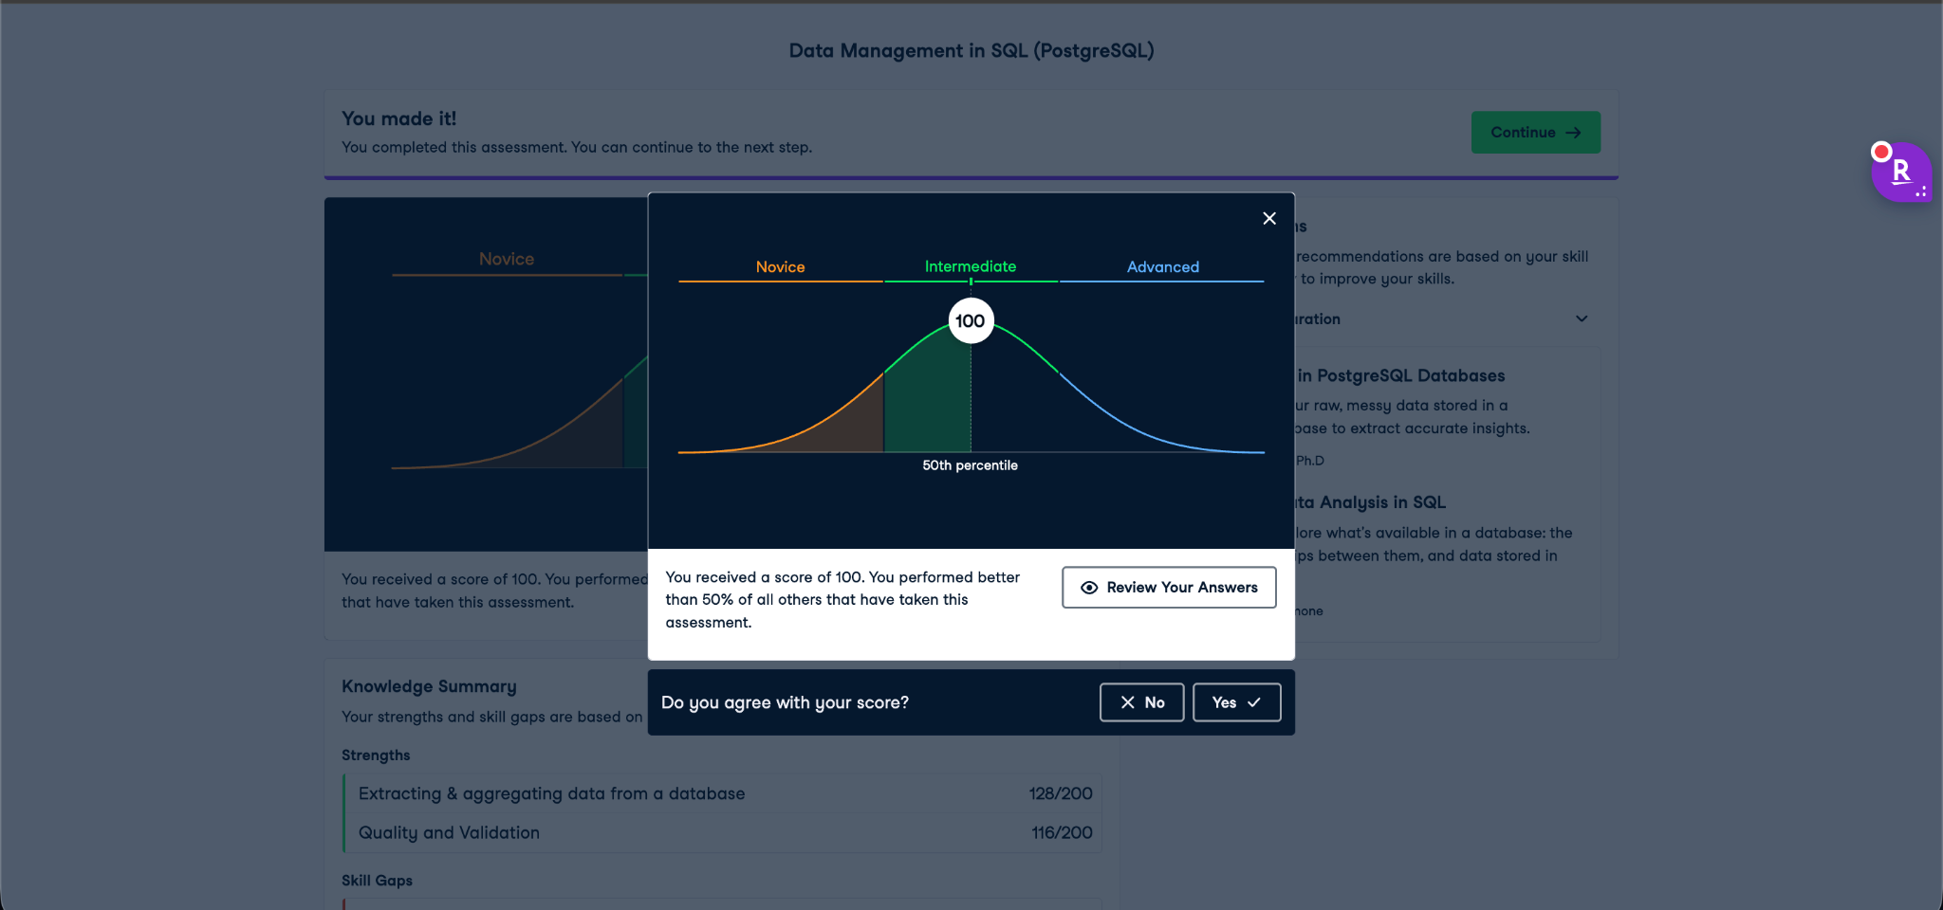

Job Search Data (M4: 2-week Sprint Data)

- Method 1: Cold Application (Quick applying, website and tailoring for 30+ mins, no referrals)
  - 70-100 Applications
  - 0 Interviews

- Method 2: Warm outreach (All before the mentorship started)
  - 5 convo
  - 5 Asked
  - 2 Referrals
  - 0 Interviews

- Method 3: Cold outreach
  - 50 Sent Connections
  - 35 Accepted
  - 25 Convos
  - 15 Asked
  - 9 Referrals
  - 3 Interviews
  - 0 2nd round Interviews

Clients Slack messages:
- “Referrals don’t work”
- “I am not qualified to be DE”
- “I don’t know anyone in USA/CA”
- “Networking is a lot of work”
- “I feel needy asking for referrals”

Booked Mock Interview Info:

- Prep Or Mock Interview: Mock
- Please Specify The Titles You Are Searching For And/Or Interviewing With: Data Engineer
- What Type Of Interview Prep/Mock You Like This Session To Be About
  - Behaviour/Screening,
  - Live Coding
  - System Design
- What Do You Want To Get Out Of This Session? I want to test my SQL live coding in a real setting and I would like to practice system design as I have only gotten 2 and failed both.
- Please Share Anything That Will Help Prepare For Our Meeting. Including Sending Google Drive Link To Your Resume, Cover Letter, GitHub And LinkedIn. Also Please Attach The Job Description If You Are Wanting A Mock.
  - JD: https://job-boards.greenhouse.io/babylist/jobs/6100946004

Task 1: Create A rough roadmap for the client to their goal (~30-60 mins)
- Gaps in client (Soft, technical and meta skills)
- Should they do a portfolio project or not? If yes include
  - Project scope
  - Skill building
  - Presenting
  - Marketing
  - Note: A project is never done, so make the project in 3-5 Minimal Viable Products (MVPs)
- What is your roadmap to get them to their goal

The main role of a mentor will be to fill in the gaps from where a client is to where they want to go, within their timeline

Task 2: Analyze their job search data, plan an escalation, and build a 2‑week roadmap (~30-45 mins)
Use the Job Search Data, Slack messages, and time audit above.
Your goal is to act as if you are their mentor today, preparing for a call with them. In the interview, you may be asked to roleplay parts of this call.
- Diagnose the current sprint (written, 0.5–1 page):
  - What are they doing well?
  - What is not working in their job search right now?
  - Which one main problem would you focus on first for the next 2 weeks?
  - Which Diamond category would you label it as (Time/Capacity, Overwhelm/Clarity, Fear/Discouragement, Strategy Gap, Other) and why?
- Design a 2‑week plan (bullet list):
  - 2–5 concrete commitments with:
    - Action (what to do)
    - Volume (how many / how often)
    - Tool or link (where it happens – tracker, LinkedIn, etc.)
    - Due dates
  - Use their time audit and energy struggles (sleep, scrolling, afternoons) when deciding what is realistic.
  - End with the exact question you would ask to check confidence (1–10) and how you would shrink the plan if they say <8.
- Escalation outline (0.5–1 page) – assume they did NOT follow the first plan well:
  - Imagine it is 2 weeks later. They completed less than half of the plan and are saying things like “referrals don’t work,” “I’m not qualified to be a DE,” and “networking is a lot of work.”
  - Using our escalation principles (Outcome + Agenda → Wins/Progress → Root Cause → 2‑week plan → Next check‑in), write a short call outline:
    - How you open and set the agenda
    - 3–5 key questions you will ask to understand wins, progress, and emotions
    - How you will name the root cause(s) in simple language
    - How you will adjust or shrink the next 2‑week plan
    - What you will do if they bring up money / wanting to pause or quit (hint: listen and handoff; do not negotiate)
- Slack message to client (5–10 lines):
  - One‑line context after the escalation call
  - Bullet list of their next actions with links + due dates
  - When you will check in next
  - One short line to encourage them and remind them of the goal

Task 3: Plan a mock interview (~30-45 mins)

Use Nachiketa’s Booked Mock Interview Info and the client’s background.
Assume they have a real upcoming process for a Sr Data Engineer role.
Your goal is to show how you would prepare, structure, and run a 30–45 minute mock so that:
- It feels like a real interview for him
- You know how you would grade each question using the rubric
- He leaves with clear feedback and concrete drills

3.1 Design the mock structure
Create a simple outline for a 45-60 minute Zoom session:
- How much time you spend on:
  - Warm‑up / framing
  - 1 behavioral question
  - 1 live SQL coding question
  - 1 system‑design question
  - Feedback and next steps
Write this as a bullet‑point timeline (for example: 5 min warm‑up, 10 min behavioral, 10 min SQL, 10 min system design, 5–10 min feedback).

3.2 Write the questions
Write three questions you would actually use with Nachiketa and the JD:
- Behavioral / screening question for a Sr DE (for example, conflict, leading a project, mentoring juniors, owning a pipeline, etc. )
- Live SQL coding question (something you could realistically do in 10–15 minutes)
- System‑design question focused on a data‑engineering problem (for example, designing a data pipeline / ingestion + transformation + serving layer)
For each question, write the exact wording you would say on the call.

3.3 Show how you would use the rubric (/10) for each question
Using the Interview Question Rubric:

Checkbox | Category | Examples
 | Paraphrasing / Clarification – Candidate restates or clarifies the question/problem before answering. | Behavioral Example: “Sure, happy to share a time I dealt with conflict.”
 |  | Problem-Solving Example: “So the inputs are X and we need Y as output — is that correct?”
 | Structure – Candidate organizes their answer using a clear framework. | Behavioral Example: Uses STAR/CAR (Situation, Task, Action, Result).
 |  | Problem-Solving Example: Uses UMPIRE, pseudocode, or system diagram to outline plan.
 | Context – Candidate provides enough background to understand the scenario or problem scope. | Behavioral Example: Provides background: who, when, where, challenge/problem.
 |  | Problem-Solving Example: Defines scope, constraints, KPIs, or business objectives.
 | Action (Ownership) – Candidate clearly explains their personal contribution or steps. | Behavioral Example: “I set up the stakeholder meeting and drafted the alignment doc.”
 |  | Problem-Solving Example: “I’d first write pseudocode, then test edge cases before coding.”
 | Result / Outcome – Candidate shares measurable results or validates the solution’s effectiveness. | Behavioral Example: “That reduced processing time by 30%.”
 |  | Problem-Solving Example: “The SQL query passes edge cases and reduces runtime to O(n).”
 | Strategic Alignment – Candidate not only evaluates trade-offs, but also connects their decision to company mission, values, or product strategy. | Behavioral Example: “I chose to mentor the intern even though it slowed me down short-term, because it aligns with our company’s value of growth and knowledge sharing.”
 |  | Problem-Solving Example: “We could use Spark for scale or Pandas for speed of iteration — given this company’s data size and cost constraints, I’d recommend Spark.”
 | Communication (Vocal Delivery) – Candidate uses the 5 vocal foundations: rate of speech, volume, pitch, tonality, and pausing. | Behavioral Example: Speaks with steady pace, clear tone, and natural pauses when telling a story.
 |  | Problem-Solving Example: Narrates reasoning while solving, varying pitch/volume to keep it engaging.
 | Body Language & Engagement – Candidate demonstrates confidence and alignment through body language and presence. | Behavioral Example: Open posture, good eye contact, expressive gestures while sharing story.
 |  | Problem-Solving Example: Maintains camera presence, leans in when explaining diagrams, avoids closed-off posture.
 | Time Management – Candidate keeps answers concise, focused, and within expected time. | Behavioral Example: Completes STAR/CAR story in ~90–120 seconds.
 |  | Behavioral Example: Balances solution depth within ~10–15 minutes coding or ~5–8 minutes case/system design.
 | Conversational Engagement – Candidate keeps the answer interactive, either mid-way or at the end. | Behavioral Example: “That’s a little about me — happy to expand if you’d like.”
 |  | Problem-Solving Example: “Would you like me to optimize for time or space here?”
0 | / 10 Score

do the following for each of the 3 questions:
- Pick 3–5 categories from the rubric that you think matter most for that specific question, write:
  - What a strong answer would look/sound like for Nachiketa
  - What a weak answer would look/sound like
- Explain briefly how you would turn that into a /10 score for the question (for example, “hits 4–5 categories strongly = 8–10, hits 2–3 partially = 5–7, <2 = 0–4”).
You are not graded on perfect SQL or architecture; we care about how you think about evaluating him using the rubric.

3.4 Feedback & homework plan
Finally, write how you would run the last 5–10 minutes of the call:
- How you would summarize his performance across the 3 questions
- How you would explain the key strengths and top 2–3 improvement areas in plain language
- What specific homework/drills you would assign for the next 7 days (for example: number of mock reps, specific question types, logging attempts in the Job Tracker, etc.)
You are the expert, not the client. Use the info he gave to decide what he actually needs.

How to Submit
Please send in one Google folder with:
- Task 1: Roadmap to goal (M1) – doc or slides
- Task 2: Task 2: Job-search diagnosis + escalation plan (M4) – doc
- Task 3: Task 3: Interview loop + mock plan (M5) – doc or slides
Name your files clearly:
YourName_Task1_M4, YourName_Task2_Escalation, YourName_Task3_M5.
Submit at least 1 hour before your next interview.

The interview will go over your plan as you will present it like you are talking to the client.

If you have any questions, please reach out. We are here to help as we are a team!

